**11.ReactJs HOL**

Create a React Application “eventexamplesapp” to handle various events of the form elements in HTML.

**React App: eventexamplesapp**

**CurrencyConverter**

import React, { useState } from 'react';

function CurrencyConverter() {

  const [amount, setAmount] = useState('');

  const [currency, setCurrency] = useState('');

  const handleSubmit = (e) => {

    e.preventDefault();

    if (!amount || isNaN(amount)) {

      alert("Please enter a valid number");

      return;

    }

    const euro = parseFloat(amount) / 90; // You can change the rate

    setCurrency(euro.toFixed(2));

  };

  return (

    <div>

      <h1 style={{ color: "green" }}>Currency Convertor!!!</h1>

      <form onSubmit={handleSubmit}>

        <label>Amount: </label>

        <input

          type="text"

          value={amount}

          onChange={(e) => setAmount(e.target.value)}

        />

        <br /><br />

        <label>Currency: </label>

        <textarea

          rows="1"

          cols="25"

          value={currency}

          readOnly

        />

        <br /><br />

        <button type="submit">Submit</button>

      </form>

    </div>

  );

}

export default CurrencyConverter;

**App.js**

import React, { useState } from 'react';

import './App.css';

import CurrencyConverter from './CurrencyConverter';

function App() {

  const [count, setCount] = useState(5);

  const increment = () => {

    setCount(count + 1);

    alert("Hello! Member1");

  };

  const decrement = () => {

    setCount(count - 1);

  };

  const sayWelcome = (msg) => {

    alert(msg);

  };

  const handleClick = (e) => {

    e.preventDefault();

    alert("I was clicked");

  };

  return (

    <div className="App">

      <h2>{count}</h2>

      <button onClick={increment}>Increment</button>

      <br /><br />

      <button onClick={decrement}>Decrement</button>

      <br /><br />

      <button onClick={() => sayWelcome("welcome")}>Say welcome</button>

      <br /><br />

      <button onClick={handleClick}>Click on me</button>

      <br /><br />

      <CurrencyConverter />

    </div>

  );

}

export default App;

**App.css**

.App {

  padding: 20px;

  font-family: Arial;

}

button {

  margin: 4px;

  padding: 4px 10px;

}

**Final Output:**

**The increase button that will increase the value and Say Hello message.**

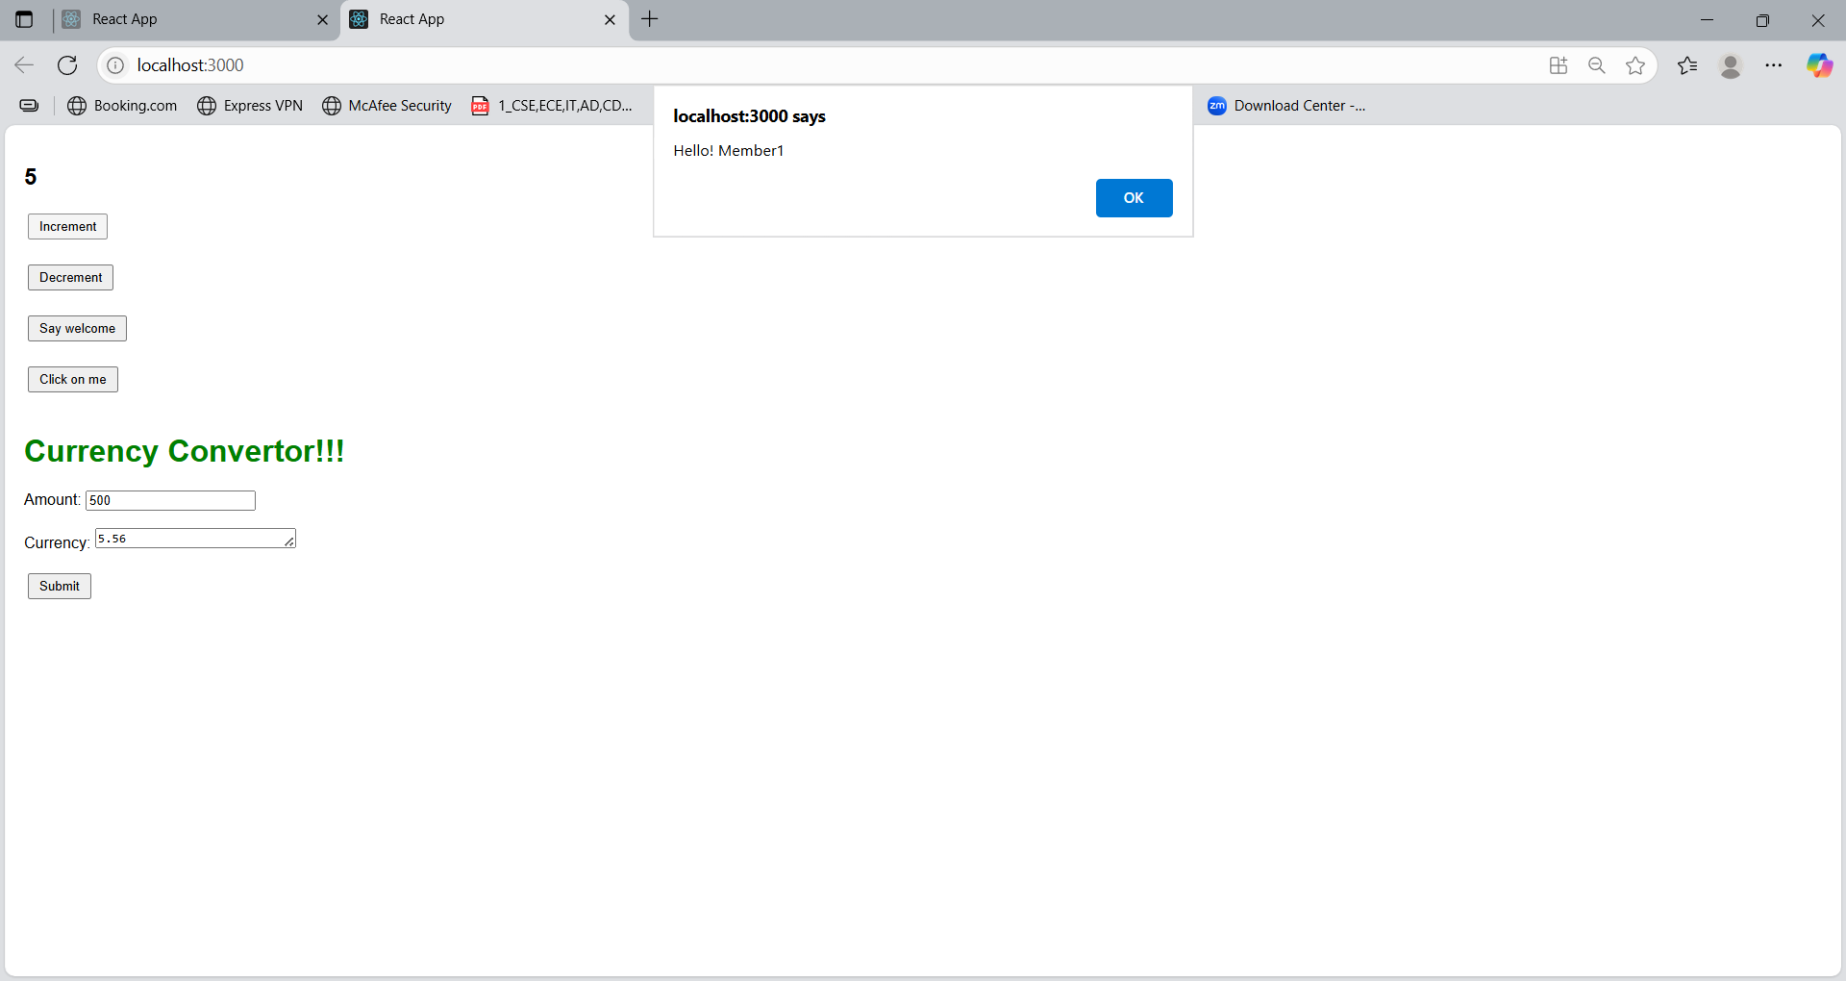

**The Say Welcome button will invokes the welcome message.**

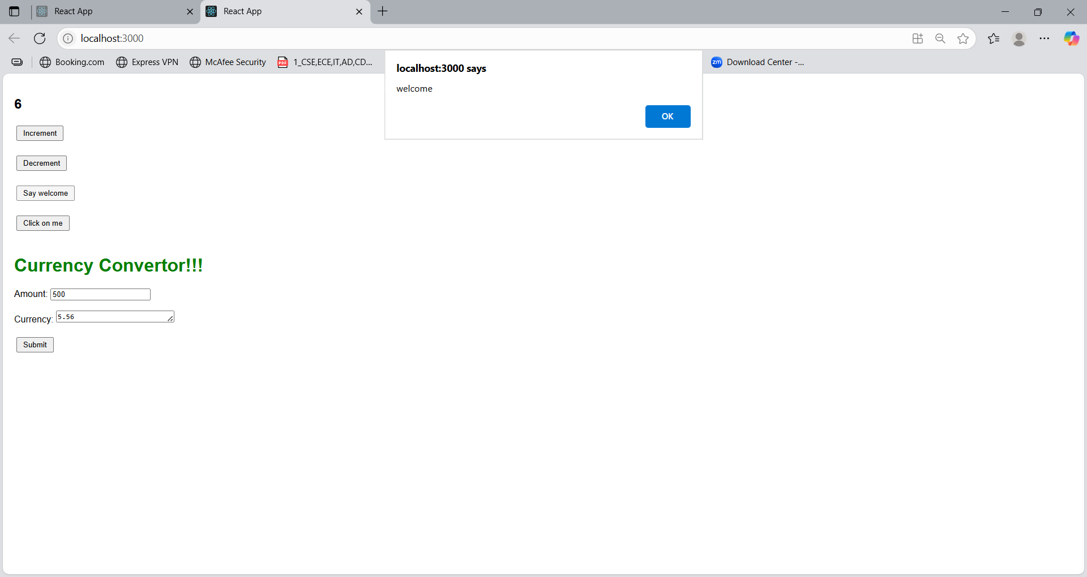

**The Click on me button will invoke I was clicked message.**

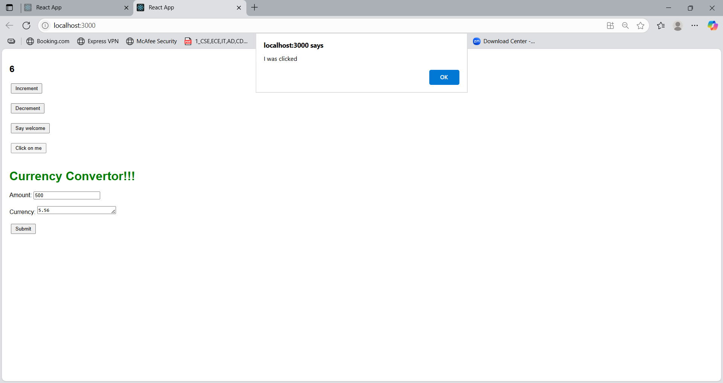

**The currency converter will convert the Indian rupees into Euro.**

